**Measurement Study of commercial Mixed Reality Platforms**

**Wireshark:**

It is mainly used to collect the packet data from network connections. So for this, the below steps can be followed:

1. Connect the Hololens to the mobile hotspot of our personal laptop that has Wireshark installed from its official website.
2. After running both devices on the same network, open the Wireshark application and wait until the WiFi network gets loopback and starts capturing the packet data.
3. Now start performing actions and after completing the experiment stop wireshark capturing.
4. Finally, you can save the packet data captured on your laptop with the .pcapng extension.

**Analysis on Wireshark packets and other data:**

1. Consider the destination IP address that has Hololen's IP address as its source. You can find this data under Conversations of Statistics.
2. To find RTT use ping. For that, open the terminal and use the command “ping IP address”. Here ip address refers to the destination IP for which you want to find RTT.
3. Use the website “ipinfo.io” to find the details like geolocation and anycast information of the destination IP.
4. Frame rate data can be found using the device portal readings that are observed during experiments.
5. CPU and GPU utilization data can be found by calculating the mean and standard deviation of the readings that are gathered for a particular duration. You can get this data from the graphs of the device portal.
6. For finding the date, time, and network protocol analyze the I/O graphs from the Wireshark application by comparing the graphical data with the packet data.

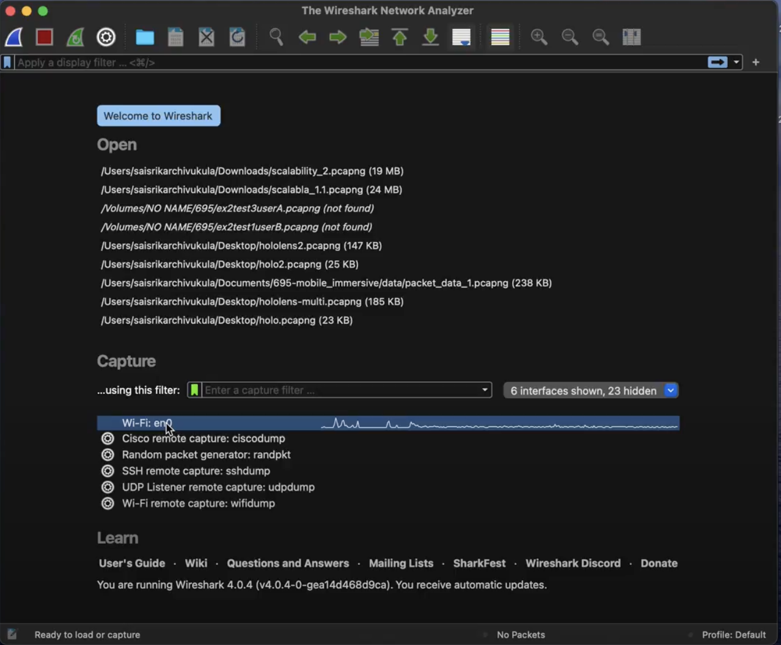

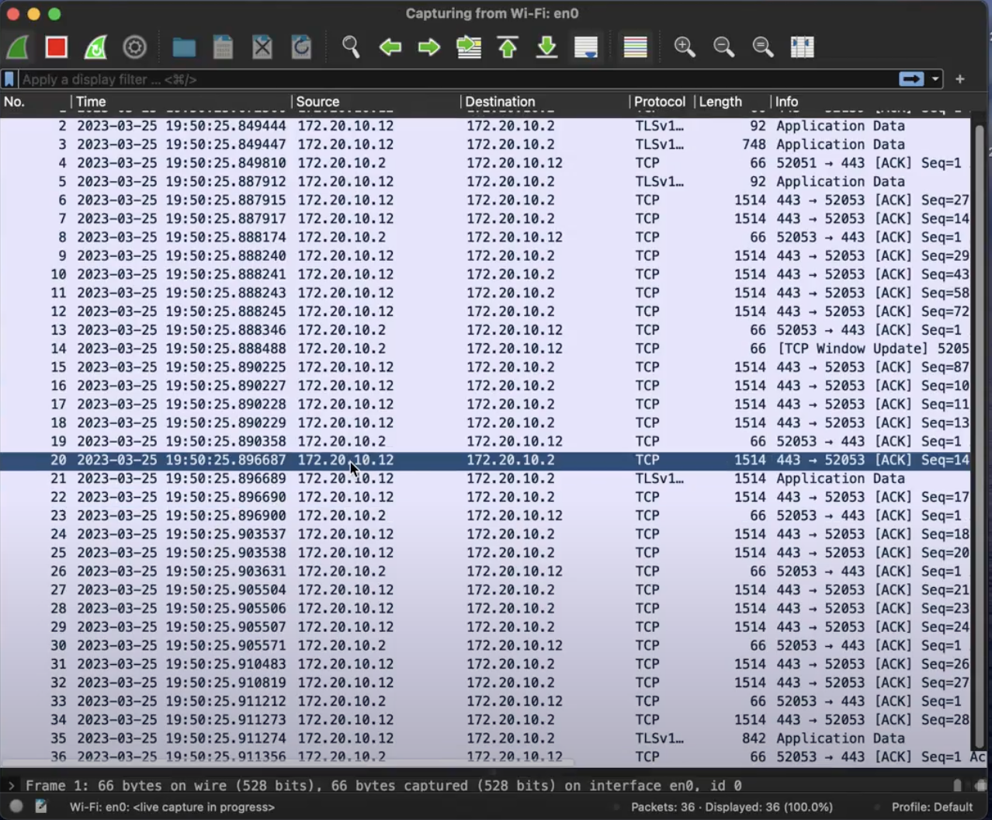

**Device Portal:**

To get the system performance data use the Windows Device portal. Below are the steps that can be followed to connect it to the Hololens:

1. Firstly, find out the IP address of Hololens by giving it a voice command saying “What is the IP address?”. Then it will display the IP address on the screen.
2. Now enter this IP address in the web browser. Then it asks for credentials so in order to reset the credentials enter the wrong details a couple of times then it will automatically redirect you to set your credentials.
3. Now you will be able to go to the Windows device portal page and in the sidebar available you can view options like View, Performance, and System. There choose the option Performance and under System Performance you can see graphs of I/O, Memory, Network, CPU, and GPU utilization.
4. In Order to display the frame rate in Hololens enable the “Display framerate counter in a headset” option provided in the Windows device portal. Now you will be able to view FPS graphs on Hololens.

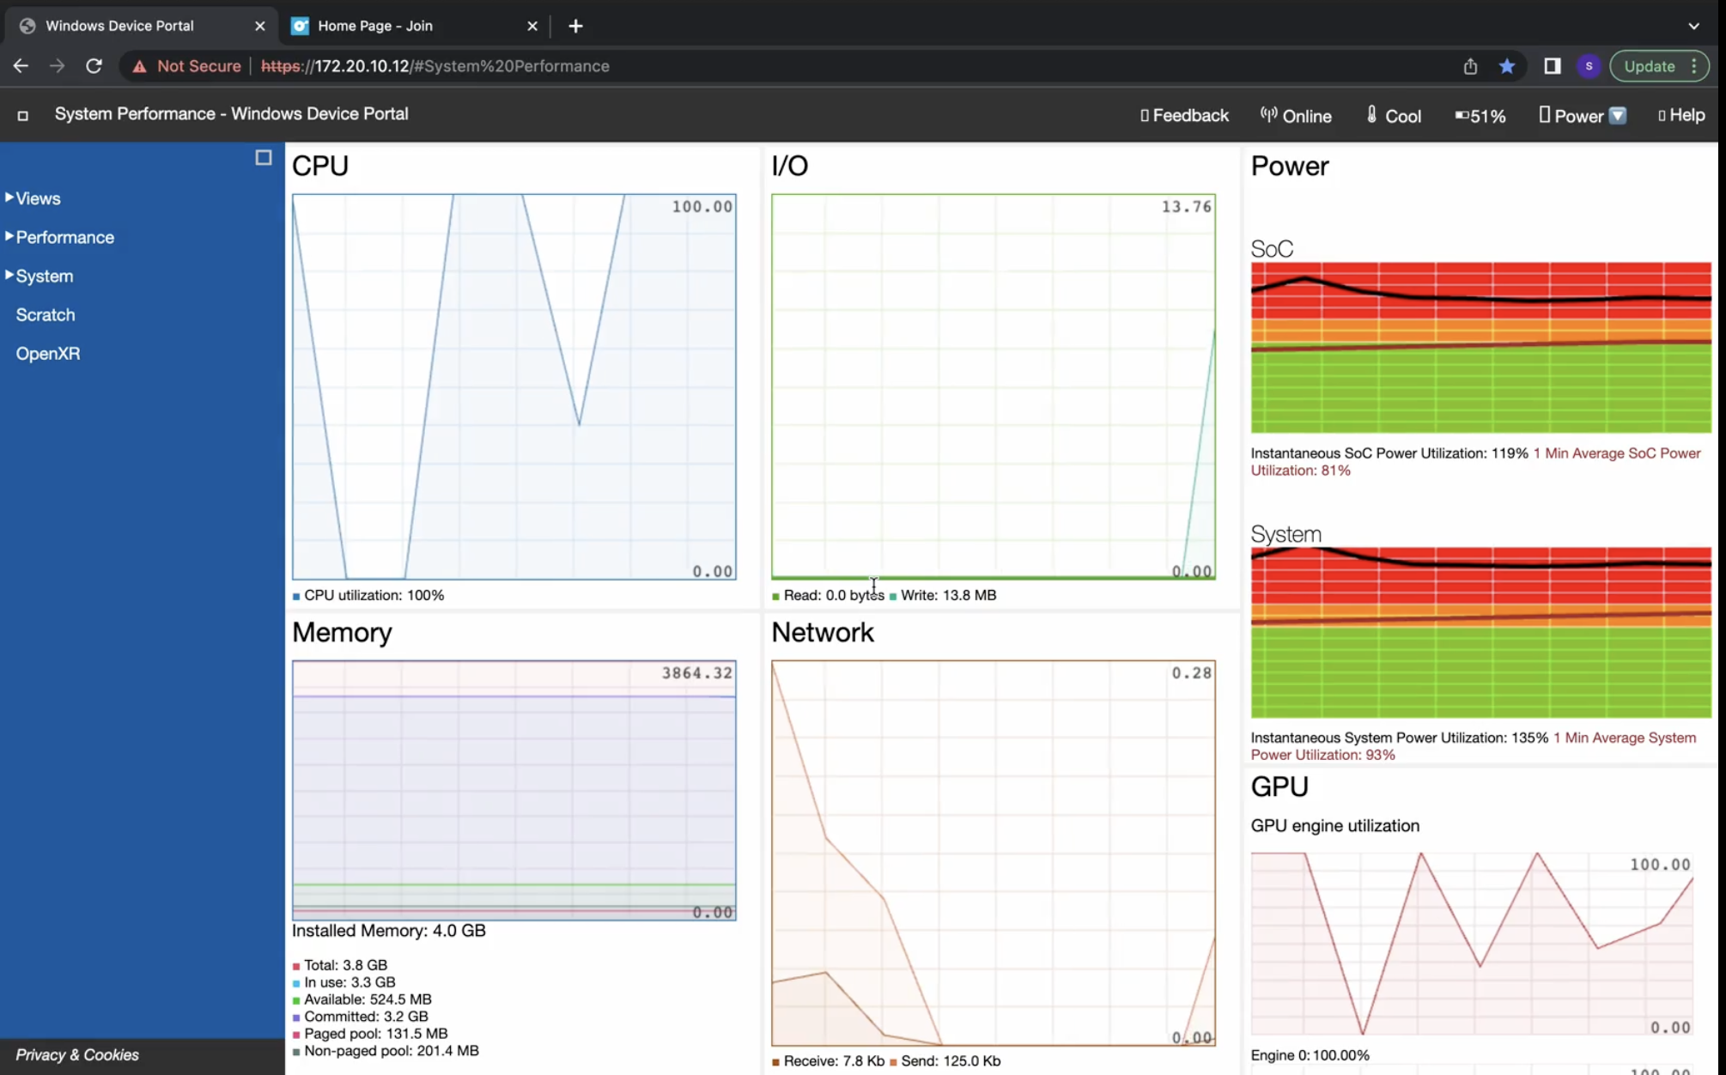

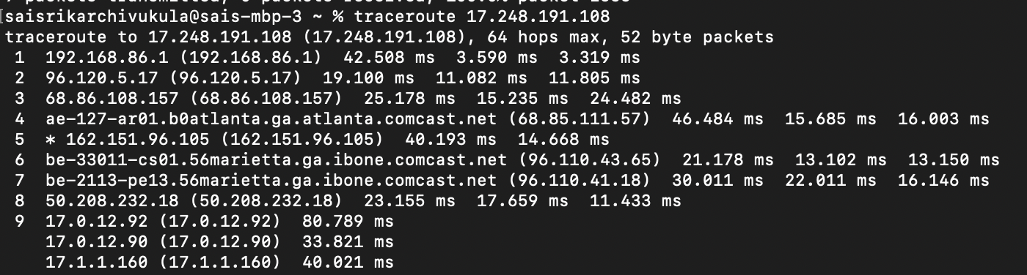

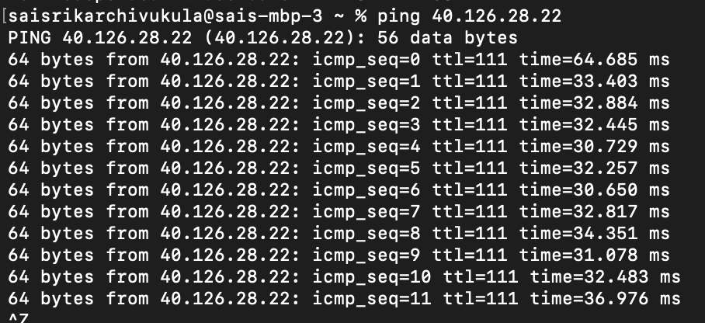

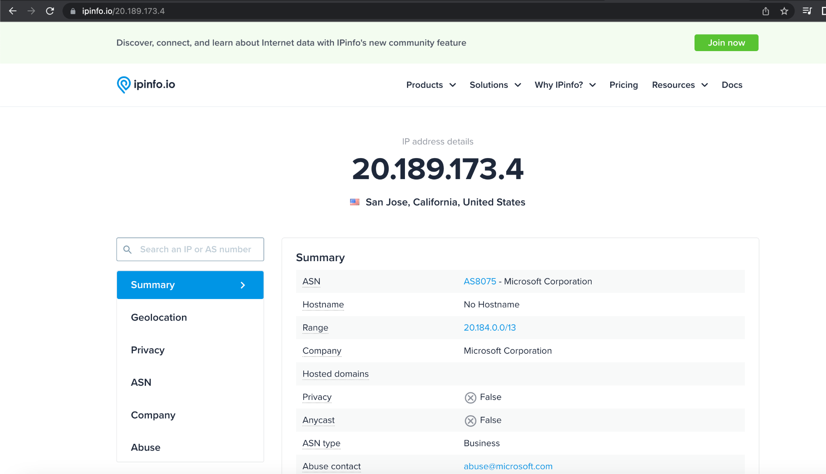

**Trace:**

To take a trace for analyzing the data using WPA use the Windows device portal. You can start taking traces under performance tracing. Now complete the required experiments and stop tracing. Finally, a file with the .etl extension will be saved on the laptop.

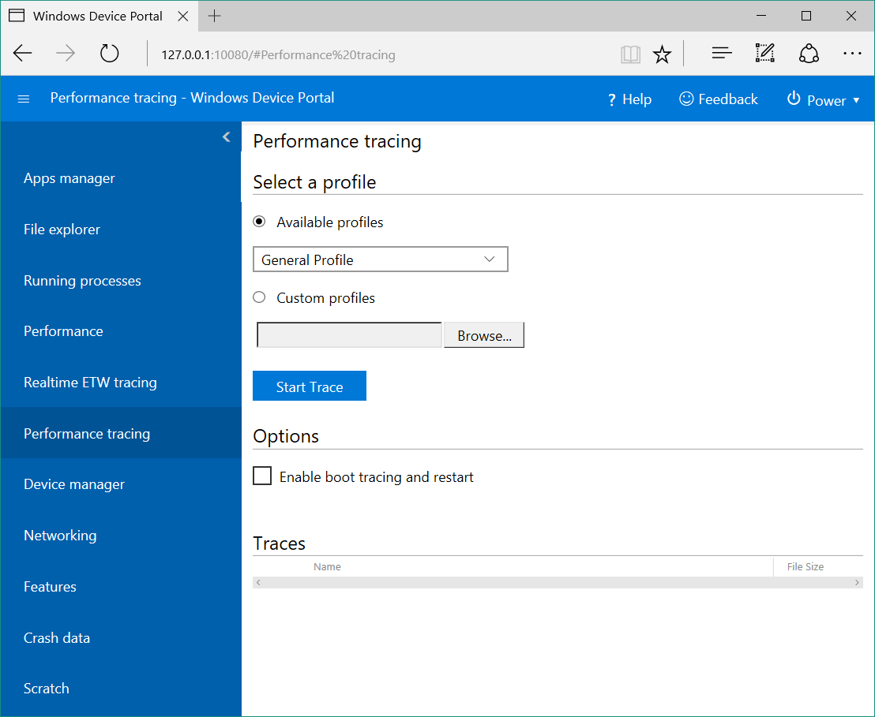

**WPA Analysis:**

1. All the above analysis can be done using both Mac and Windows laptops but WPA analysis can only be done using Windows laptops. For this Windows Performance Analysis(WPA) application should be used which can be installed from the Windows store.
2. After installing the application, open the .etl file in this application and start your analysis.
3. CPU utilization can be found under Computation which is present on the left side of the app.
4. Performed the experiments to find the Hololens application-specific data. For instance, for your experiments if you use the JoinXR application. You can get the CPU utilization of the JoinXR application separately instead of considering the CPU utilization of complete Hololens.
5. You can directly get the JoinXR application’s CPU utilization data by considering the weight of the JoinXR.exe data.

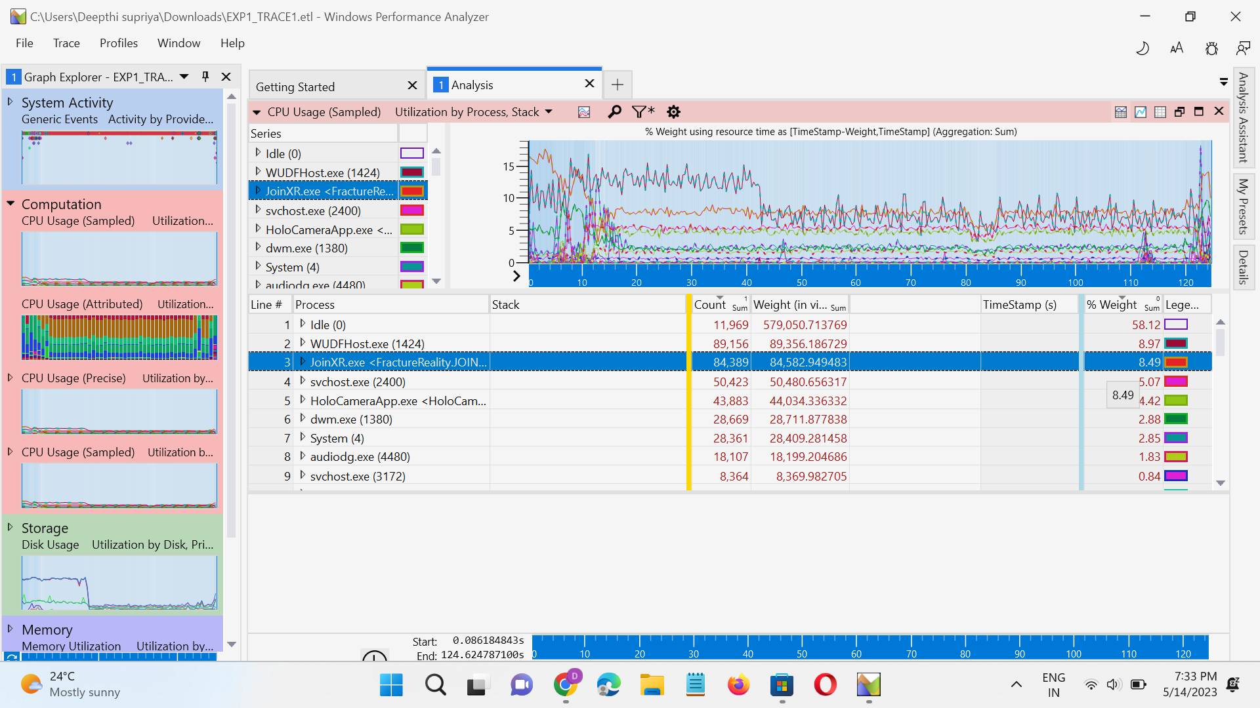

1. In the same way, to find out the Memory utilization, you need to consider the resident set and then click on the “Utilization by process” option on the top, after which you will get a dropdown menu. From there select the process private working set and then choose the Active option. Here you can find the applications that are actively utilizing the Hololens. Here consider the data used by the JoinXR application which is in mb.

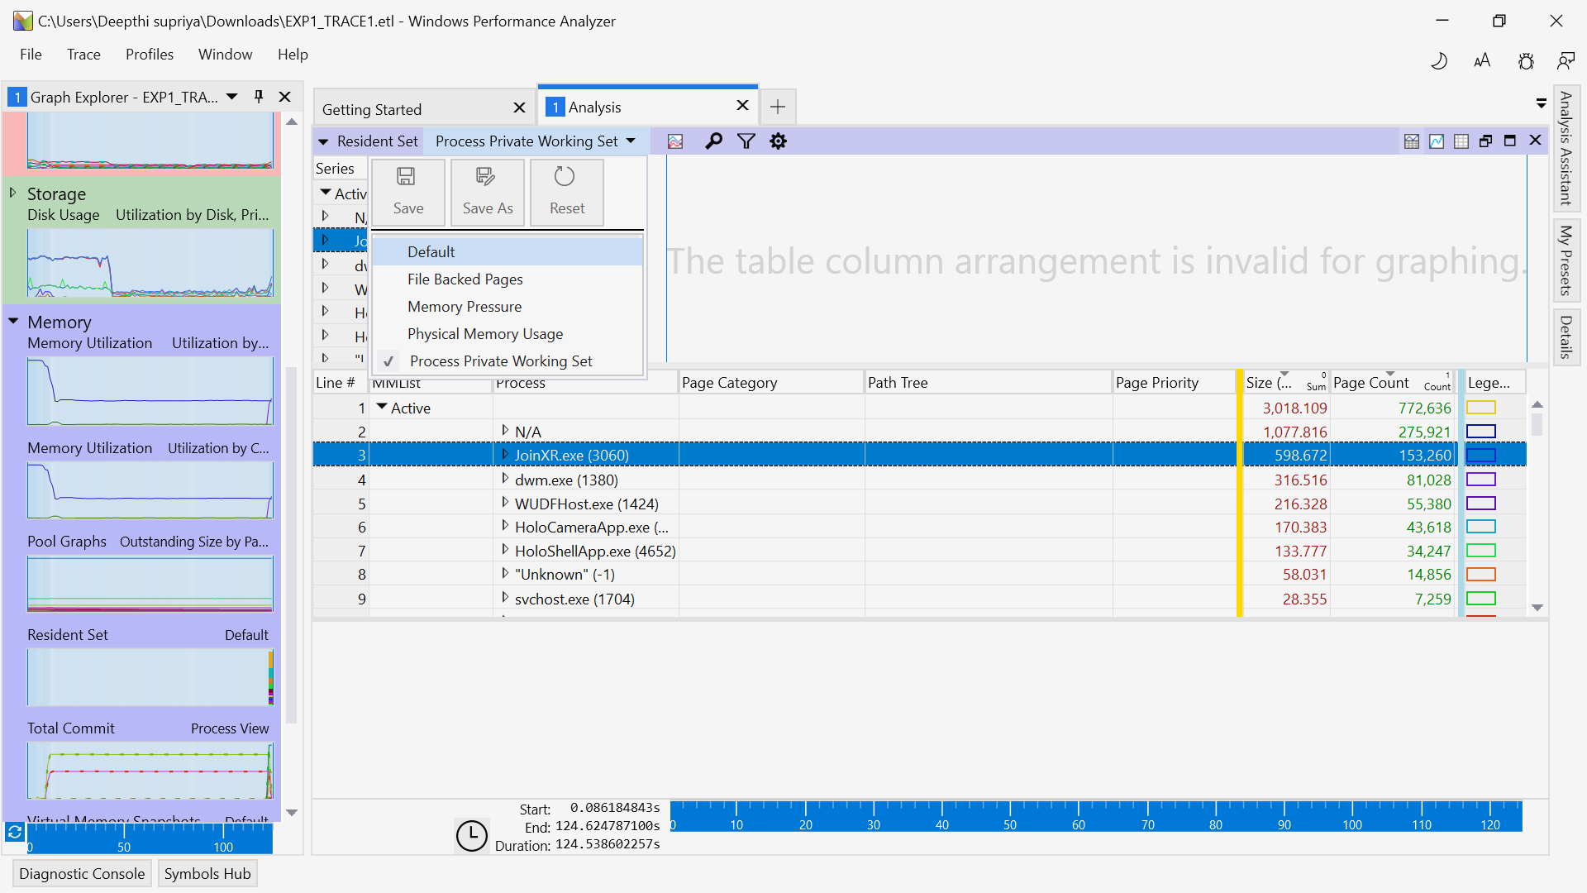

**References used:**

1. <https://www.wireshark.org/> Use this website to download the Wireshark application.
2. Use this website to understand the usage of Wireshark application <https://www.wireshark.org/docs/wsug_html_chunked/ChapterIntroduction.html>
3. Use this website to understand the usage of the Windows Performance analyzer. <https://learn.microsoft.com/en-us/windows-hardware/test/wpt/windows-performance-analyzer>
4. Use this link to download WPA <https://apps.microsoft.com/store/detail/windows-performance-analyzer/9N0W1B2BXGNZ>
5. Use this website to understand the usage of Windows Device Portal <https://learn.microsoft.com/en-us/windows/uwp/debug-test-perf/device-portal>
6. Use this website to find geolocation and anycast <https://ipinfo.io/>.

Naga Rajeswari Pravallika Mannuru(G01361795)

Srikar Chivukula(G01339210)